MiSACWIS Project

IV13 – Record Classification Screen Specification
Version 3.5

October 28, 2015
Prepared for:


120 N. Washington Square
SACWIS Project, 3rd Floor
Lansing, MI 48933

Prepared by:

Revision Log
Version | Date | A/D/C (Add, Delete, Change) | Author | Document Section # | Description
0.1 | 08/09/2011 |  | P. Rasher |  | Initial version
0.2 | 12/13/2011 |  | P. Rasher | All | Pre-JAD revisions
0.3 | 12/19/2011 |  | P. Rasher | 3.1.2, 3.1.3, 3.2.2, 3.2.3, 3.3.2, 3.4.2 | Pre-JAD revisions
0.4 | 12/20/2011 |  | P. Rasher | 3 | JAD Day 3 revisions
0.5 | 12/21/2011 |  | P. Rasher | 3.1 | JAD Day 4 revisions
0.6 | 12/22/2011 |  | P. Rasher | 3.1 | JAD Day 4 revisions
0.7 | 01/03/2012 |  | P. Rasher | 3.1.3 | Change new attribute names per ART
0.8 | 01/04/2012 |  | K. Stone | All | Day 8 JAD review
1.0 | 01/05/2012 |  | K. Stone | All | Day 9 JAD Approval
1.1 | 03/15/2012 |  | K. Stone | 3.2.5 | Changes based on change control: 6333
1.2 | 03/21/2012 |  | K. Stone | 3.2.5 | Made changes based on change control 6333.
1.3 | 03/23/2012 |  | P. Rasher | 3.2, 3.3, 3.4 | Changes for CQ 6333
1.4 | 04/03/2012 |  | K. Stone | All | Changes for CQ 6683
1.5 | 04/05/2012 |  | K. Stone | 3.3.5 | Reference to one of the SMEs in the document was removed.
1.6 | 04/09/2012 |  | P. Rasher | 3.3.2 | Approved CQ 6333
1.7 | 04/11/2012 |  | K. Stone | 3.3.5, 3.2.5.24 | Presented CQ 6683 to DHS BAs. Approved this date. All track changes accepted.
1.8 | 04/30/2012 |  | P. Rasher | 3.1, 3.2, 3.3, 3.4 | CC#8090
1.9 | 05/01/2012 |  | K. Stone | 3.2.5 | Changes based on CQ 8090
1.10 | 05/08/2012 | D | K. Stone | 3.2.5 | CQ changes 8090 presented to and approved by DHS BAs.
2.0 | 08/06/2012 | A | Mike Stubbs | 3.2.5.33 | CQ changes 8254 presented to and approved by DHS BAs.
2.1 | 08/17/2012 | C | P. Rasher | 3.2.2, 3.2.3, 3.3.2, 3.3.3, 3.4.2, 3.4.3 | Additional revisions for CC#8254 reviewed and approved
2.2 | 10/05/2012 | C | P. Rasher | 3.4.2, 3.4.4 | CC#19673 add, remove buttons
2.3 | 10/11/2012 | C | P. Rasher | 3.4.3 | CC#20076 trendsOrPatternsComments size
2.4 | 09/30/2013 | C | M. Stubbs | 3.3.5.2 | CQ 44190  Modified duplication of maltreatment types rules
2.4 | 10/02/2013 |  | P. Rasher |  | CQ 44190 review/signoff
3.0 | 06/25/2014 | C, A, D | P. Rasher | 3.1.2, 3.1.3, 3.2.2, 3.2.3, 3.2.5#33, 34, 35, 3.3.2, 3.3.3, 3.3.5#1, 2, 5 | CQ 60366 One tier allegations, Narrative Entered column
3.1 | 07/01/2014 | C, D | P. Rasher | 2.1.5, 3.2.2, 3.2.4, 3.3.3, 3.4.2, 3.4.3 | CQ 60366 Document updates: CPS History and Trends, Allegation Type drop-down
3.2 | 07/03/2014 | C | P. Rasher | 3.1.3 | CQ#24996 Investigation header
3.3 | 08/12/2015 | A, C | P. Rasher | 3.2.2, 3.2.3,3.2.5#36-41 , 3.3.2, 3.3.3, 3.3.5#7-8, 3.4.2, 3.4.3 | CQ#78648 Child Death checkbox and Secondary Role for AP
3.4 | 10/06/2015 | A | P. Rasher | 3.2.5#42 | CQ#97502 If a Child Death flag is checked, an AV must be deceased.
3.5 | 10/23/2015 | A | P. Rasher | 3.2.5#43 | CC#98780 If AV is age 18 or older, finding must be No Preponderance.
Table of Contents
1 Introduction 7
1.1 Purpose 7
1.2 Scope 7
2 Use Case Details 8
2.1.1 Action Buttons/Hyperlinks 8
2.1.2 Business Rules 8
2.1.3 Security Requirements 8
2.1.4 Screen Navigation 9
2.1.5 Tab Order 9
2.1.6 Pre-Conditions 9
2.1.7 Ticklers 9
2.1.8 Notifications 10
2.1.9 Calendar 10
2.1.10 Reports 10
2.1.11 Notes and Assumptions 10
3 Screen Details 11
3.1 S01 – Caregiver Risk Factors Screen 11
3.1.1 As Is – Screen Mock Up 11
3.1.2 To Be – Screen Mock Up 12
3.1.3 Screen Fields 13
3.1.4 Action Buttons 20
3.1.5 Business Rules 20
3.1.6 Screen Navigation 21
3.1.7 Pre-Conditions 21
3.1.8 Reference Values 21
3.1.9 Notes and Assumptions 21
3.2 S02 – Classification Information Screen 22
3.2.1 As Is – Screen Mock Up(After Classifications Approval) 22
3.2.2 To Be – Screen Mock Up (After Findings Approval) 22
3.2.3 Screen Fields 24
3.2.4 Action Buttons 27
3.2.5 Business Rules 28
3.2.6 Screen Navigation 33
3.2.7 Pre-Conditions 33
3.2.8 Reference Values 33
3.2.9 Notes and Assumptions 33
3.3 S03 – Allegation Details Screen 34
3.3.1 As Is – Screen Mock Up 34
3.3.2 To Be – Screen Mock Up 34
3.3.3 Screen Fields 35
3.3.4 Action Buttons 39
3.3.5 Business Rules 39
3.3.6 Screen Navigation 41
3.3.7 Pre-Conditions 41
3.3.8 Reference Values 41
3.3.9 Notes and Assumptions 42
3.4 S04 – Classification Details Screen 43
3.4.1 As Is – Screen Mock Up 43
3.4.2 To Be – Screen Mock Up 44
3.4.3 Screen Fields 45
3.4.4 Action Buttons 48
3.4.5 Business Rules 48
3.4.6 Security Requirements 49
3.4.7 Screen Navigation 50
3.4.8 Pre-Conditions 50
3.4.9 Reference Values 51
3.4.10 Notes and Assumptions 51

List of Figures
Figure 1 – Caregiver Risk Factors – Existing Screen Mock Up 11
Figure 2 – Caregiver Risk Factors – Updated Screen Mock Up 12
Figure 3 – Classification Information – Existing Screen Mock Up 22
Figure 4 – Findings Information – Updated Screen Mock Up 23
Figure 5 – Allegation Details – Existing Screen Mock Up 34
Figure 6 – Allegation Details – Updated Screen Mock Up 34
Figure 7 – Classification Details – Existing Screen Mock Up 43
Figure 8 – Classification Details – Updated Screen Mock Up 44

- Introduction
  - Purpose
This use case is to allow workers to document classification information and risk factors within an investigation.
  - Scope

This document describes the screens design for the IV13 – Record Classification use case based on the screen specs created for this same use case which include Caregiver Risk factors, Classification information and Allegation detail.

- Use Case Details

    - Action Buttons/Hyperlinks
Status (Keep/Add/Modify/Delete) | Label | Type | On Click Action/Navigation
NA
    - Business Rules
No. | Status (Keep/Add/Modify/Delete) | Business Rule Description | Modified Business Rule Description | Execution Event (field tab out/save etc) | Error Msg Code  To be completed by Development Team
    - Security Requirements
No. | Status (Keep/Add/Modify/Delete) | Security Requirement
1 | Keep | Create:  CPS Worker
2 | Keep | Read:  Worker
3 | Keep | Update:  CPS Worker
4 | Keep | Delete:  CPS Worker
    - Screen Navigation
No. | Status (Keep/Add/Modify/Delete) | To Screen Navigation Path
NA
    - Tab Order
No. | Status (Keep/Add/Modify/Delete) | Screen name
1 | Modify | Findings>CPS History and Trends
    - Pre-Conditions
No. | Status (Keep/Add/Modify/Delete) | Pre-Condition
1 | Keep | An intake has been linked to an investigation.
    - Ticklers
Status (Keep/Add/Modify/Delete) | Tickler Name | Trigger Action | Tickler Generation Business Rule & Description | Tickler Removal Business Rule | Tickler Text
Status (Keep/Add/Modify/Delete) | Tickler Role
 | N/A
    - Notifications
Status (Keep/Add/Modify/Delete) | Notification Name | Trigger Action | Message Business Rule & Description | Message Text
Status (Keep/Add/Modify/Delete) | Notification Role | Trigger Action | Message Business Rule & Description | Message Text
 | N/A
    - Calendar
Status (Keep/Add/Modify/Delete) | Calendar Name | Trigger Action | Calendar Event Generation Business Rule & Description | Calendar Event Date and Time Business Rule | Calendar Event Text
Status (Keep/Add/Modify/Delete) | Calendar Role
 | N/A
    - Reports
    - Notes and Assumptions

- Screen Details
  - S01 – Caregiver Risk Factors Screen
    - As Is – Screen Mock Up
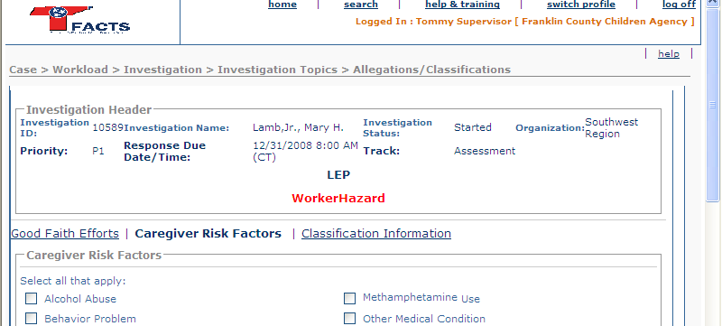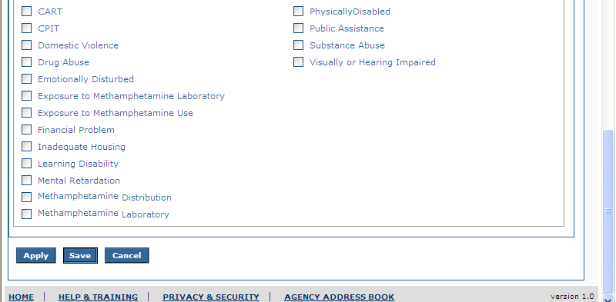
Figure 1 – Caregiver Risk Factors – Existing Screen Mock Up

    - To Be – Screen Mock Up
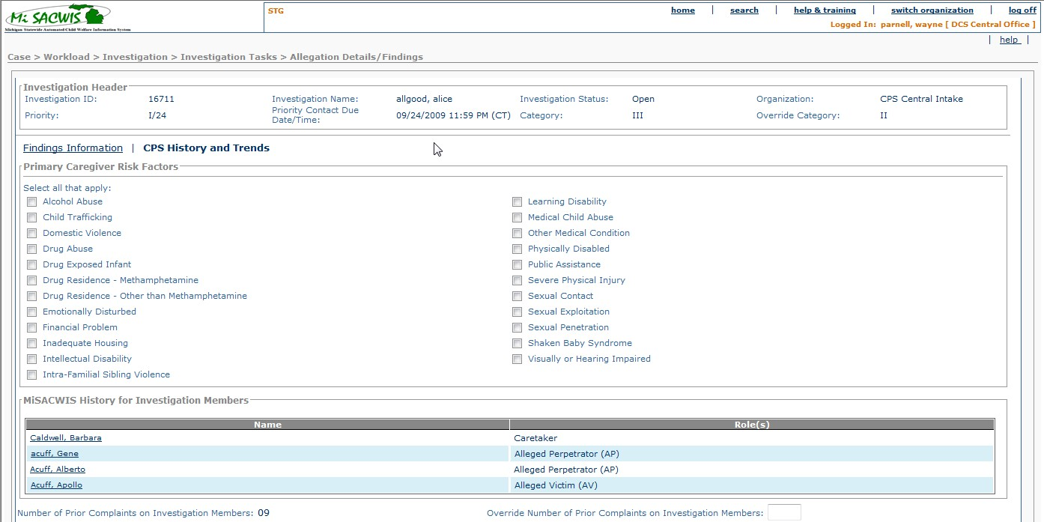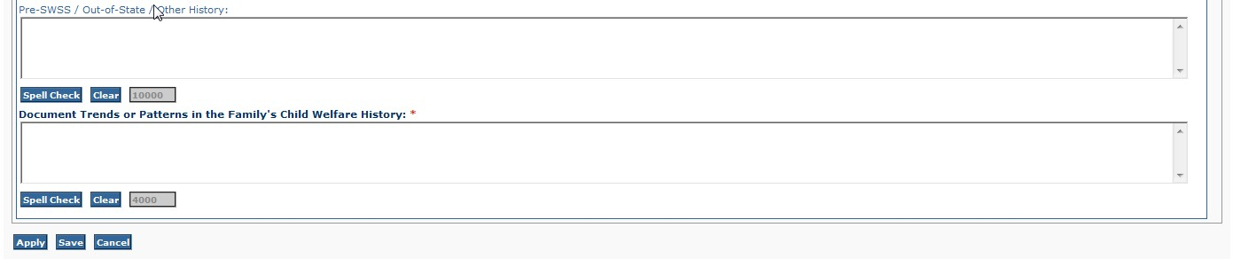
Figure 2 – Caregiver Risk Factors – Updated Screen Mock Up
    - Screen Fields
Status (Unchanged/Add/Modify/Delete) | As Is Class.Attribute Name | To Be Class.Attribute Name | As Is Display Name | To Be Display Name | To Be Type | To Be Align | To Be Size | To Be Read Only | To Be Calculation | To Be Edit Mask | To Be UI Validation
Modify | N/A | N/A | Caregiver Risk Factors | Primary Caregiver Risk Factors | Hyperlink in Focus | L | N/A | T | N/A | N/A | N/A
Keep | N/A | N/A | Investigation Header | Investigation Header | Group Box Label | L | N/A | T | N/A | N/A | N/A
Modify | INVESTIGATION.investigationId | INVESTIGATION.caseId | Investigation ID | Investigation ID | Header Information | L | 22 | T | N/A | N/A | N/A
Modify | INTAKEPARTICIPANT.lastName + INTAKEPARTICIPANT.firstName + INTAKEPARTICIPANT.middleName  (Note: if person not established, use above)  OR  PERSON.lastName + PERSON.firstName + PERSON.middleName  (Note: if person established, use above) | PERSON.lastName + PERSON.firstName + PERSON.middleName | Investigation Name | Investigation Name | Header Information | L | 110 | T | Where PersonId = Investigation.PersonId with Investigation.InvReferencePersonFlag = true | N/A | N/A
Keep | INVESTIGATION.investigationStatusCode | INVESTIGATION.investigationStatusCode | Investigation Status | Investigation Status | Header Information | L | 30 | T | N/A | N/A | N/A
Keep | AGENCY.agencyName | AGENCY.agencyName | Organization | Organization | Header Information | L | 100 | T | Where AgencyId=CaseAgencyLink.LocalAgencyId of the WorkloadItem WorkAssignment | N/A | N/A
Modify | INTAKE.currentPriority | INTAKE.currentPriority | Priority | Priority | Header Information | L | 30 | T | The priority is the highest “current priority” of any intake linked to this investigation. | N/A | Display in normal font; do not bold.
Modify | INVESTIGATION.responseDueDateTime | INVESTIGATION.responseDueDateTime | Response Due Date/Time | Priority Contact Due Date/Time | Header Information | L | 10 | T | N/A | UI Standardized Date  MM/DD/YYYY | Display in normal font; do not bold.
Add | N/A | Investigation.DispositionCategoryCode | N/A | Category | Display text | L | 100 | T | N/A | Domain code = CATEGORYDISPOSITION | N/A
Add | N/A | DUEPROCESS.overrideCategoryCode | N/A | Override Category | Display text | L | 100 | T | From most recent DueProcess for the investigation if any. Domain Code = DISPOSITIONCATEGORY | N/A | N/A
Delete | INTAKE.currentTrack | INTAKE.currentTrack | Track | Track | Header Information | L | 30 | T | N/A | N/A | System derived not worker modified  Once the first intake is linked to an investigation, the investigations track is set to agree with that intake. Subsequent intakes linked to this investigation must have the same track.
Keep | INTAKEPARTICIPANT.workerHazardFlag | INTAKEPARTICIPANT.workerHazardFlag | Worker Hazard indicator  (Header “Worker Hazard”.) | Worker Hazard indicator  (Header “Worker Hazard”.) | Header | L | 22 | T | This flag is set when one or more Safety Hazards are selected on the Person Safety Hazards screen. | N/A | System derived based on person profile(s) of linked Intake participants.
Keep | INTAKEPARTICIPANT.lepFlag | INTAKEPARTICIPANT.lepFlag | LEP (limited English proficiency) | LEP (limited English proficiency) | Header | L | 22 | T | System derived based on person profile(s) of linked Intake participants. | N/A | Taken from the Person Demographics screen – flag that interpreter is needed.
Modify | N/A | N/A | Caregiver Risk Factors | CPS History and Trends | Group Box Header | L | N/A | T | N/A | N/A | N/A
Keep | N/A | N/A | Select all that Apply: | Select all that Apply: | Header | L | N/A | T | N/A | N/A | N/A
Keep | RiskFactors.riskFactorCode | RiskFactors.riskFactorCode | N/A | N/A | Check Boxes | L | N/A | F | Domain Code:  CaregiverRiskFactor | N/A | User selected checkboxes  Not required  See BR 1
Add | N/A | Investigation | N/A | MiSACWIS History for Investigation Members | Header | L | N/A | N/A | N/A | N/A | N/A
Add | N/A | Person.Lastname + Person.Firstname + Person.Middlename | Name | Name | Display text | C | 110 | F | N/A | N/A | User selectable  Name will show as a hyperlink.
Add | N/A | Investigationpersonrole.investigPersonRoleCode | N/A | Role(s) | Display text | C | 30 | T | N/A | N/A | N/A
Add | N/A | Investigation.PriorComplaintCount | N/A | Number of Prior Complaints on Investigation Members: | Display text | L | 22 | T | Sum of distinct CPS Intakes on members of the investigation; do not count an intake more than once. | N/A | N/A
Add | N/A | Investigation.OverrideComplaintCount | N/A | Override Number of Prior Complaints on Investigation Members | Text field | L | 3 | F | N/A | N/A | User input  Not required
Add | N/A | Investigation.PriorHistoryComments | N/A | Pre-SWSS / Out-of-State / Other History: | Text field | L | 10000 | F | N/A | N/A | User input  Not required
Add | N/A | Investigation.TrendsOrPatternsComments | N/A | Document Trends or Patterns in the Family’s Child Welfare History: | Text field | L | 10000 | F | N/A | N/A | User input  Required

    - Action Buttons
Status (Keep/Add/Modify/Delete) | Label | Type | On Click Action/Navigation | Tab Order
Keep | Apply | Button | Saves Data entered and stays on this screen
Keep | Save | Button | Saves data entered and returns to IV20 – S02 Investigation Tasks
Keep | Cancel | Button | Does not accept data entered and removes the page/screen; returns to IV20 – S02 Investigation Topics Tasks
Delete for SOM | Good Faith Efforts | Hyperlink | System presents IV22- S01 Good Faith Efforts
Modify | Classification Findings Information | Hyperlink | System presents IV13 – S02 Classification Information
Keep | Spell Check | Button | Invokes spell check on the associated text box.
Keep | Clear | Button | Clears the text from the associated text box.
Keep | Spell Check | Button | Invokes spell check on the associated text box.
Keep | Clear | Button | Clears the text from the associated text box.

    - Business Rules
No. | Status (Keep/ Add/ Modify/ Delete) | Business Rule Description | Modified Business Rule Description | Execution Event (field tab out/save etc) | Error Msg Code  To be completed by Development Team
1 | Modify | The ref data list of caregiver risk factors available must be frozen when the initial intake is linked to the investigation(at investigation create), so that if there is an update to the ref data list at a later time this new list does not overwrite the original list for the investigation in focus on IV13 –S01 Caregiver Risk Factors.  Subsequent intakes that are linked to this investigation in focus will use the same ref data list that was frozen at the first intake. | The ref data list of caregiver risk factors available must be frozen when the initial intake is linked to the investigation(at investigation create), so that if there is an update to the ref data list at a later time this new list does not overwrite the original list for the investigation in focus on IV13 –S01 Primary Caregiver Risk Factors.  Subsequent intakes that are linked to this investigation in focus will use the same ref data list that was frozen at the first intake. | When first intake is linked to investigation.
    - Screen Navigation
No. | Status (Keep/Add/Modify/Delete) | To Screen Navigation Path
1 | Modify | Case>Workload>Investigation>Investigation Topics Tasks>Allegation Classification Details / Findings hyperlink>Caregiver Risk Factors hyperlink
2 | Modify | Search Hyperlink>Case>Click Hyperlink for desired investigation>Investigation Topics Tasks >Allegation Details /Classifications Findings hyperlink>Caregiver Risk Factors hyperlink
3 | Modify | Case>Workload>Case>Investigation Linked>Investigation ID>Investigation Topics Tasks >Allegations Details /Classifications Findings hyperlink>Caregiver Risk Factors hyperlink
    - Pre-Conditions
No. | Status (Keep/Add/Modify/Delete) | Pre-Condition
1 | Keep | Investigation must exist
    - Reference Values
No. | Status (Keep/ Add/ Modify/ Delete) | To Be Class Attribute | Domain Code | Short Desc | Ref Data Code
1 | Keep |  | CaregiverRiskFactor

    - Notes and Assumptions
Modify navigation so that the landing screen for selecting the hyperlink Allegation Details/Findings on IV20 S02 Investigation Tasks is IV13 S02 Findings Information, not IV13 S01 Primary Caregiver Risk Factors.
  - S02 – Classification Information Screen
    - As Is – Screen Mock Up(After Classifications Approval)
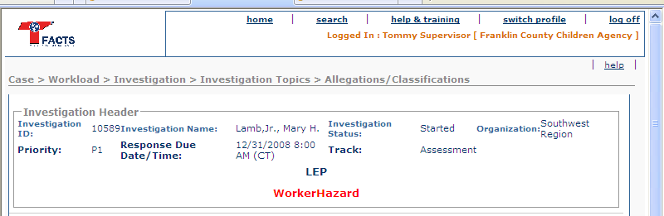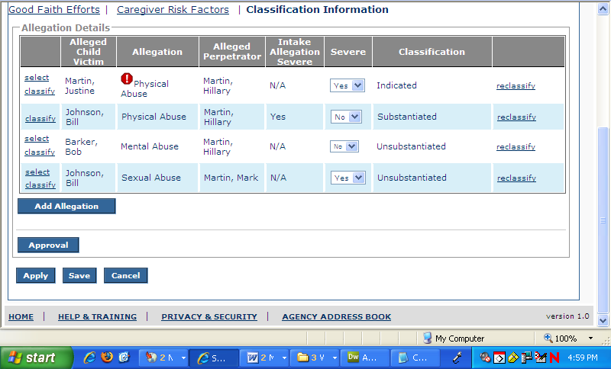
Figure 3 – Classification Information – Existing Screen Mock Up
    - To Be – Screen Mock Up (After Findings Approval)
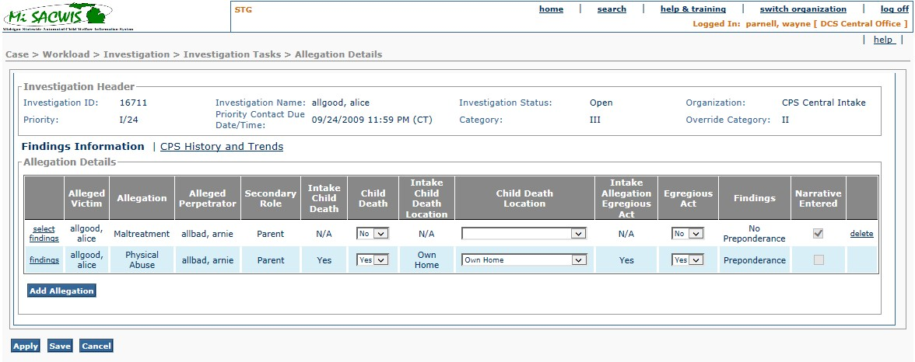Figure 4 – Findings Information – Updated Screen Mock Up
    - Screen Fields
Status (Unchanged/Add/Modify/Delete) | As Is Class.Attribute Name | To Be Class.Attribute Name | As Is Display Name | To Be Display Name | To Be Type | To Be Align | To Be Size | To Be Read Only | To Be Calculation | To Be Edit Mask | To Be UI Validation
See Header Information in section 3.1.3
Modify | N/A | N/A | Classification Information | Findings Information | Hyperlink In Focus | L | N/A | T | N/A | N/A | N/A
Keep | N/A | N/A | Allegation Details | Allegation Details | Group Box Header | L | N/A | T | N/A | N/A | N/A
Keep | N/A | N/A | <No Label> | <No Label> | First Column | C | N/A | T | N/A | N/A | This column can contain  - Select  - Findings  Hyperlinks  See BR 5 and 7
Modify | INVESTIGATIONALLEGATION.allegedChildVictim | INVESTIGATIONALLEGATION.allegedChildVictim | Alleged Child Victim | Alleged Victim | Display text | C | 22 | T | N/A | Last Name, First Name, MI | N/A
Keep | ALLEGATIONCLASSIFICATION.allegationTypeCode | ALLEGATIONCLASSIFICATION.allegationTypeCode | Allegation | Allegation | Display text | C | 30 | T | Domain code=AllegationType | N/A | N/A  See BR 4a
Delete | N/A | AllegationClassification.AllegationSuperTypeCode | N/A | Allegation Type | Display text | C | 100 | T | Domain code=AllegationCategory | N/A | N/A
Keep | INVESTIGATIONALLEGATION.allegedPerpetrator | INVESTIGATIONALLEGATION.allegedPerpetrator | Alleged Perpetrator | Alleged Perpetrator | Display text | C | 22 | T | N/A | N/A | N/A
Add | N/A | Investigationpersonrole.investigPersonRoleCode | N/A | Secondary Role | Display text | C | 100 | T | Where InvestigationPersonRole.investigPersonId = InvestigationAllegation.allegedPerpetrator in focus  Domain code=ParticipantRole | N/A | Display the role(s) of this Alleged Perpetrator that are other than AP. See BR#41
Add | N/A | Allegation.childDeathFlag | N/A | Intake Child Death | Display text | C | 100 | T | Yes if 1, No if 0 | N/A | Display information from linked intake for this allegation  See BR#36
Add | N/A | AllegationClassification.childDeathFlag | N/A | Child Death | Dropdown List | C | 100 | F | Domain Code = YesNo | N/A | If null, default to Allegation.childDeathFlag if the allegation was created at Intake (investigationAllegation.allegationId is not null) else blank.  See BR#37
Add | N/A | Allegation.childDeathLocationCode | N/A | Intake Child Death Location | Display text | C | 100 | T | Domain code = ChildDeathLocation | N/A | Display information from linked intake for this allegation  See BR#36
Add | N/A | AllegationClassification.childDeathLocationCode | N/A | Child Death Location | Dropdown List | C | 100 | F | Domain code = ChildDeathLocation | N/A | Disabled unless allegationClassification.childDeathFlag=1  If null, default to Allegation.childDeathLocationCode if the allegation was created at Intake (investigationAllegation.allegationId is not null) else blank.  See BR#38
Modify | ALLEGATION.severeFlag | ALLEGATION.severeFlag | Intake Allegation Severe | Intake Allegation Egregious Act | Display text | C | 22 | T | N/A | N/A | Information pulled from linked intake for this allegation  See BR14
Modify | ALLEGATIONCLASSIFICATION.severeFlag | ALLEGATIONCLASSIFICATION.severeFlag | Severe | Egregious Act | Display text | C | 22 | T | N/A | N/A | Severity defaults to Information pulled from linked intake for this allegation  See BR 4A
Modify | ALLEGATIONCLASSIFICATION.classificationTypeCode | ALLEGATIONCLASSIFICATION.classificationTypeCode | Classification | Findings | Display text | C | 30 | T | N/A | N/A | Information pulled from IV13- S04 Classification Details Screen. Classification Drop Down  See BR 4a
Add | N/A | N/A | N/A | Narrative Entered | Checkbox | C | N/A | T | If the AllegationClassification.ClassificationNarrative is not null, display checked box else display unchecked box | N/A | System derived
Modify | N/A | N/A | <No Label> | <No Label> | Last Column | C | N/A | T | N/A | N/A | This column will contain the ‘Delete’ Hyperlink  See BR 6  This column will also contain the ‘reclassify recategorize’ hyperlink.

    - Action Buttons
Status (Keep/ Add/ Modify/ Delete) | Label | Type | On Click Action/Navigation | Tab Order
Keep | Add Allegation | Button | System presents IV13 – S03 Edit Allegation Screen; returns to IV13 – S02 Classification Information  See BR10
Delete | Approval | Button | System presents CF14 – Process Approval ;returns to IV13 – S02 Classification Information  See BRs 2, 3, 8, 9, 15, 16, 21, 22, & 23.
Keep | Select | Hyperlink | System presents IV13 – S03 Edit Allegation Screen; returns to IV13 – S02 Classification Information  See BR 5
Modify | Classify Findings | Hyperlink | System presents IV13 – S04 Classification Details Screen returns to IV13 – S02 Classification Information  See BR 7
Delete for SOM | Good Faith Efforts | Hyperlink | System Presents IV22 – S01 Good Faith Efforts Screen
Modify | CPS History and Trends | Hyperlink | System Presents IV13 – S01 Caregiver Risk Factors
Keep | Delete | Hyperlink | System will delete selected allegation set; stay on this screen  See BR 6
Keep | Apply | Button | Saves Data and stays on screen
Keep | Save | Button | Saves data entered; returns to IV20 – S02 Investigation Topics
Keep | Cancel | Button | Does not accept data enters and removes the page/screen; to IV20 – S02 Investigation Topics
Delete | Reclassify Recategorize | Hyperlink | System Presents IV24 – S01 Reclassification History
    - Business Rules
No. | Status (Keep/ Add/ Modify/ Delete) | Business Rule Description | Modified Business Rule Description | Execution Event (field tab out/save etc) | Error Msg Code  To be completed by Development Team
1 | Delete | The “Was Methamphetamine a contributing factor in this investigation?” field on IV21 –S01 Investigation Persons must not be null. |  | When Approval Button is selected
2 |  | Retain for BR number
3 |  | Retain for BR number
4a | Modify | The values shown in the Allegation Details grid on the Classification Information screen will be based on the latest classification information or latest reclassification information.  If reclassification information is displayed, then place the “flag” indicating that the allegation has been reclassified to the left of the allegation in the Allegation Details grid on the Classification Information screen. | The values shown in the Allegation Details grid on the Classification Findings Information screen will be based on the latest classification findings information. | Page Load
5 | Modify | The ‘select’ hyperlink should only be available to the user for allegations entered at the investigation level and until classification (s) are submitted for approval (unless classifications returned for rework). | The ‘select’ hyperlink should only be available to the user for allegations entered at the investigation level and until classification finding(s) are submitted for approval (unless findings returned for rework). | Page Load
6 | Modify | The ‘delete’ hyperlink should only be available to the user for allegations entered at the investigation level and until classification(s) are submitted for approval (unless classifications returned for rework). | The ‘delete’ hyperlink should only be available to the user for allegations entered at the investigation level. and until findings are submitted for approval (unless findings returned for rework). | Page Load
7 | Modify | The ‘classify’ hyperlink will be available in update-mode to the user until classification(s) are submitted for approval (unless classifications returned for rework). Once the classification has been approved, the ‘classify’ hyperlink needs to be available in read-only mode. | The ‘findings’ hyperlink will be available in update-mode to the user until findings are submitted for approval (unless findings returned for rework). Once the findings have been approved, the ‘findings’ hyperlink needs to be available in read-only mode. | Page Load
9 | Modify | Any Safety Assessment or SIU Safety/Risk Assessment associated to the investigation in focus must be in “Approved” status before the classifications are submitted for approval.  Any IPA associated to a safety assessment that is associated to the investigation in focus must be in ‘Discontinued’ status (ref IV23-S12 Discontinue IPA) | Any Safety Assessment or Risk Assessment associated to the investigation in focus must be in “Approved” status before the investigation is submitted for approval.  Any IPA associated to a safety assessment that is associated to the investigation in focus must be in ‘Discontinued’ status (ref IV23-S12 Discontinue IPA) | “Approval” Button
10 | Modify | After the allegation classifications are approved, no new allegations may be added. | After the allegation findings are approved, no new allegations may be added. | Add Allegation Button
11 |  | Retain for BR number
12 |  | Retain for BR number
13 |  | Retain for BR number
14 | Modify | If an allegation is added at the investigation level, the “Intake Allegation Severe” column will default to “N/A” | If an allegation is added at the investigation level, the “Intake Allegation Egregious Act” column will default to “N/A” | Page Load
15 | Keep | When CF14 is called set the uniqueness flag to “True”. Person submitting for approval cannot be the approver. |  | Approval Button
16 | Keep | When CF14 is called, the action of “Deny” should not be an option |  | Approval Button
17 | Modify | When status of classification approval is “Pending Approval”, all information on the Classification Information Screen becomes read-only. Except the approval button. This also includes IV13 – S03 Allegation Details and IV13 – S04 Classification Details. | When status of findings approval is “Pending Approval”, all information on the Findings Information Screen becomes read-only. Except the approval button. This also includes IV13 – S03 Allegation Details and IV13 – S04 Classification Details. | Page Load
18 | Modify | When status of classification approval is “Reviewed”, all information on the Classification Information Screen becomes read-only. Except the approval button. This also includes IV13 – S03 Allegation Details and IV13 – S04 Classification Details | When status of findings approval is “Reviewed”, all information on the Findings Information Screen becomes read-only. Except the approval button. This also includes IV13 – S03 Allegation Details and IV13 – S04 Classification Details | Page Load
19 | Modify | When status of classification approval is “Recalled”, all information on the Classification Information Screen becomes read-only. Except the approval button. This also includes IV13 – S03 Allegation Details and IV13 – S04 Classification Details | When status of findings approval is “Recalled”, all information on the Findings Information Screen becomes read-only. Except the approval button. This also includes IV13 – S03 Allegation Details and IV13 – S04 Classification Details | Page Load
20 | Modify | When status of classification approval is “Approved”, all information on the Classification Information Screen becomes read-only. Except the approval button. This also includes IV13 – S03 Allegation Details and IV13 – S04 Classification Details | When status of findings approval is “Approved”, all information on the Findings Information Screen becomes read-only. Except the approval button. This also includes IV13 – S03 Allegation Details and IV13 – S04 Classification Details | Page Load
21 | Keep | Before an investigation can be closed, all safety assessments (IV06 Record Safety Assessment) associated to the investigation must have a status value of “Approved”. | Before an investigation can be closed and if there are multiple safety assessments, all safety assessments (IV06 – Record Safety Assessment) must be in approved status. | Approval Button
22 | Keep | Before an investigation can be closed, any SIU Safety/Risk Assessment (IV06a SIU Safety Assessment) within the investigation must have a status value of “Approved”. |  | Approval Button
23 | Keep | Before an investigation/case can be closed, all Immediate Protection Agreements (IPAs) (IV23 Record IPA) associated to any safety assessment that is associated to the investigation must have a status value of “Discontinued”. |  | Approval Button
24 | Delete | If a face to face contact has NOT been recorded for each investigation participant with a role of alleged child victim with a Contact Date / Time earlier than or equal to the Response Time for the Investigation / Assessment AND a good faith effort of type "Response Time Not Met" has NOT been recorded THEN provide error message. |  | Approval Button
32 | Add | If on IV13 S04 a user selects Preponderance in the Findings dropdown list and  IF on IV13 S01, the user selects “Yes” in the “Egregious Act” dropdown list and clicks Save,  Then  present a pop up window that says, “A preponderance of evidence has been found for an egregious act in this investigation. If the investigation is approved, a notification will be sent to DHS Central Office for confirmation.” |  | Save Button
33 | Add | Each allegation must have a Finding (AllegationClassification. classificationTypeCode); if any allegation does not have a Finding, display an error message. |  | Apply/Save
34 | Add | Each allegation must have a Findings Detail Narrative (AllegationClassification. classificationNarrative); if any allegation does not have a Findings Detail Narrative, display an error message. |  | Apply/Save
35 | Add | The Document Trends and Patterns in the Family’s Welfare History narrative (Investigation. TrendsOrPatternsComments) must be provided; if this narrative is null, display an error message. |  | Apply/Save
36 | Add | If an allegation is added at the investigation level, the “Intake Child Death” and “Intake Child Death Location” columns will display as “N/A” |  | Page Load
37 | Add | If allegationClassification. childDeathFlag is null (not yet set): if the allegation was created at Intake (investigationAllegation. allegationId is not null) then set selection to Allegation.childDeathFlag value (Yes if 1, No if 0) else set selection to blank. |  | Page load
38 | Add | If allegationClassification. childDeathLocationCode is null (not yet set): if the allegation was created at Intake (investigationAllegation. allegationId is not null) then set selection to Allegation. childDeathLocationValue value else set selection to blank. |  | Page load
39 | Add | If allegationClassification. childDeathFlag=1, the child’s person.deceasedDate may not be null. |  | Apply/Save
40 | Add | Each Investigation participant who has the role of Alleged Perpetrator (InvestigationPersonRole. investigPersonRoleCode=’AP’) must also have at least one additional role. |  | Apply/Save  and  Findings
41 | Add | The role(s) of the Alleged Perpetrator other than ‘Alleged Perpetrator (AP)’ are displayed in the column Secondary Role |  | Page load
42 | Add | If any participant who is an Alleged Victim has a Person record with the Deceased Flag checked or a non-null Deceased Date, then at least one allegation must have the Child Death box checked. |  | Apply/Save
43 | Add | Verify that each Allegation that has an Alleged Victim who is age 18 years or older as of the intake complaint date (intake.receivedDate) as calculated from their Person record Date of Birth or Estimated Age, has the finding of No Preponderance. The individual(s) who fail this verification will be identified by name in the error message. |  | Apply/Save

    - Screen Navigation
No. | Status (Keep/Add/Modify/Delete) | To Screen Navigation Path
1 | Modify | Case>Workload>Investigation>Investigation Topics Tasks>AllegationsClassifications Details /Findings hyperlink>Classification Findings Information hyperlink
2 | Modify | Search Hyperlink>Case>Click Hyperlink for desired investigation>Investigation Topics Tasks > Classifications Findings hyperlink>Classification Findings Information hyperlink
3 | Modify | Case>Workload>Case>Investigation Linked>Investigation ID>Investigation Topics Tasks >Allegations Classifications Details/Findings hyperlink>Classification Findings Information hyperlink
    - Pre-Conditions
No. | Status (Keep/Add/Modify/Delete) | Pre-Condition
1 | Keep | Investigation must exist.
2 | Keep | Investigation needs to be tracked as “Investigation”, “Assessment”, or “Special Investigation(SIU)”
    - Reference Values
No. | Status (Keep/Add/Modify/Delete) | To Be Class Attribute | Domain Code | Short Desc | Ref Data Code
 | N/A

    - Notes and Assumptions
Modify navigation so that the landing screen for selecting the hyperlink Allegations Details/Findings on IV20 S02 Investigation Tasks is IV13 S02 Findings Information, not IV13 S01 Primary Caregiver Risk Factors.
Currently the same error message is displayed for 1) a missing Finding, 2) a missing Findings Detail Narrative and/or 3) no “Document Trends and Patterns in the Family’s Welfare History” narrative; Business rules 33, 34 and 35 specify that a unique and appropriate error message be displayed, if necessary, for each condition.
  - S03 – Allegation Details Screen

As Is – Screen Mock Up
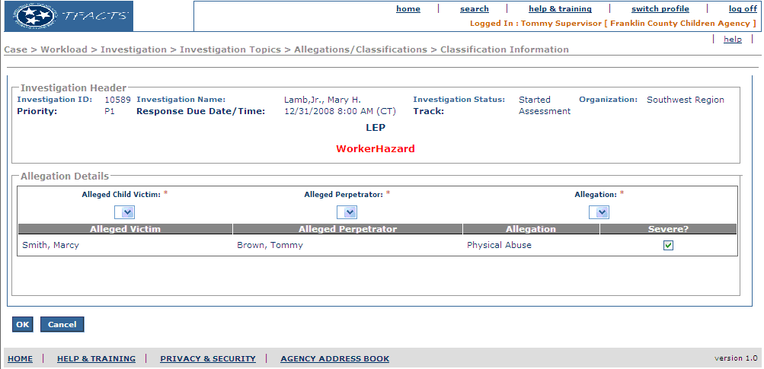
Figure 5 – Allegation Details – Existing Screen Mock Up

    - To Be – Screen Mock Up
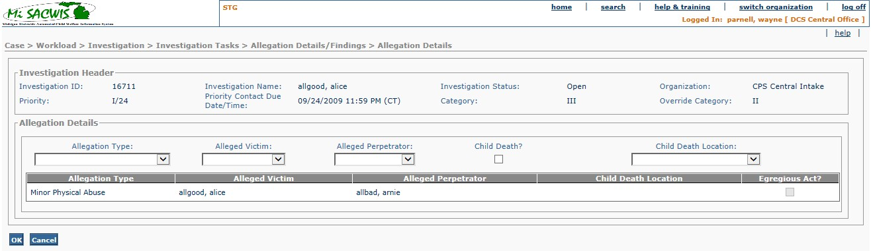Figure 6 – Allegation Details – Updated Screen Mock Up
    - Screen Fields
Status (Unchanged/Add/Modify/Delete) | As Is Class.Attribute Name | To Be Class.Attribute Name | As Is Display Name | To Be Display Name | To Be Type | To Be Align | To Be Size | To Be Read Only | To Be Calculation | To Be Edit Mask | To Be UI Validation
See Header Information in section 3.1.3
Keep | N/A | N/A | Allegation Details | Allegation Details | Group Box Header | L | N/A | T | N/A | N/A | N/A
Modify | INVESTIGATIONALLEGATION.allegedChildVictim | INVESTIGATIONALLEGATION.allegedChildVictim | Alleged Child Victim | Alleged Victim | Drop Down List | L | 100 | F | N/A | Last Name, First Name MI | User Selected  Required Field  Default to Null  List populated from IV21 – S02 Investigation Persons Details with all established investigation persons(have person id) with role of Alleged Child Victim  See BR 2
Keep | INVESTIGATIONALLEGATION.allegedPerpetrator | INVESTIGATIONALLEGATION.allegedPerpetrator | Alleged Perpetrator | Alleged Perpetrator | Drop Down List | L | 100 | F | N/A | Last Name, First Name MI | User selected  Required Field  Default to Null  List populated from IV21 – S02 Investigation Persons Details with all established investigation persons(have person id) with role of Alleged Perpetrator  See BR 2
Modify | ALLEGATIONCLASSIFICATION.allegationTypeCode | ALLEGATIONCLASSIFICATION.allegationTypeCode | Allegation | Allegation | Drop Down List | L | 30 | F | Domain Code:  AllegationType | N/A | User selected  See BR 2  Required Field  Default to Null
Delete | N/A | AllegationClassification.AllegationSuperTypeCode | N/A | Allegation Type | Drop Down List | L | 100 | F | Domain code: AllegationCategory is filtered by the selected domain code AllegationType value | N/A | User selected  Field enabled once an Allegation is selected.
Keep | INVESTIGATIONALLEGATION.allegedChildVictim | INVESTIGATIONALLEGATION.allegedChildVictim | Alleged Victim | Alleged Victim | Display text | L | 22 | T | N/A | Last Name, First Name MI | N/A
Keep | INVESTIGATIONALLEGATION.allegedPerpetrator | INVESTIGATIONALLEGATION.allegedPerpetrator | Alleged Perpetrator | Alleged Perpetrator | Display text | L | 22 | T | N/A | Last Name, First Name MI | N/A
Modify | ALLEGATIONCLASSIFICATION.allegationTypeCode | ALLEGATIONCLASSIFICATION.allegationTypeCode | Allegation | Allegation | Display text | L | 30 | T | Domain code=AllegationType | N/A | N/A
Delete | N/A | AllegationClassification.allegationSuperTypeCode | N/A | Allegation Type | Display text | L | 100 | T | Domain code=AllegationCategory | N/A | System populated
Modify | ALLEGATIONCLASSIFICATION.severeFlag | ALLEGATIONCLASSIFICATION.severeFlag | Severe? | Egregious Act? | Check Box | L | 22 | F | N/A | N/A | N/A
Add | N/A | AllegationClassification.childDeathFlag | N/A | Child Death? | Checkbox | L | N/A | F | N/A | N/A | N/A
Modify | N/A | AllegationClassification.ChildDeathLocationCode | N/A | Child Death Location | Drop Down List | L | 100 | F | Domain Code = ChildDeathLocation | N/A | Disabled unless Child Death? Checkbox is checked.  Conditionally required required if Child Death? Is checked, see BR#7  User selected
Modify | N/A | AllegationClassification.ChildDeathLocationCode | N/A | Child Death Location | Display text | L | 100 | T | N/A | N/A | System populated

    - Action Buttons
Status (Keep/ Add/ Modify/ Delete) | Label | Type | On Click Action/Navigation | Tab Order
Keep | Ok | Button | Caches Information; return to IV13 – S02 Classification Information  See BR 6
Keep | Cancel | Button | Does not accept data enters and removes the page/screen; returns to IV13 – S02 Classification Information
    - Business Rules
No. | Status (Keep/ Add/ Modify/ Delete) | Business Rule Description | Modified Business Rule Description | Execution Event (field tab out/save etc) | Error Msg Code  To be completed by Development Team
1 | Modify | If any of the following allegation information is modified on IV13- S03 Allegation Details:  - “Alleged Child Victim”  - “Alleged Perpetrator”  - “Allegation”  Then clear the following information on IV13 –S04 Classification Details for the allegation:  - “Classification”  - “Classification Details Narrative”  Warn User prior to this action. | If any of the following allegation information is modified on IV13- S03 Allegation Details:  - “Alleged Child Victim”  - “Alleged Perpetrator”  - “Allegation ”  Then clear the following information on IV13 –S04 Classification Details for the allegation:  - “Findings”  - “Findings Details Narrative”  Warn User prior to this action. | OK button
2 | Modify | When adding/modifying allegations from within the investigation, the user must not be able to create a duplication of this allegation set (which includes ACV, AP, allegation) that already exists within the investigation in focus. | Do not allow duplicate entry of  Allegation  (where Allegation Type Domain Code =AllegationCategory) (Allegation. AllegationTypeCode)  , Alleged Victim and Alleged Perpetrator.  Do not allow the duplication of maltreatment types among unique pairings of AV/AP. For example, if sexual abuse is selected for the pairing on AV “A” and AP “A”, do not allow sexual abuse to be selected again for AV “A” and AP “A”. | OK Button
2a |  | Retain for BR number
3 |  | Retain for BR number
4 | Modify | If Allegation Details are populated from an intake, default “Severe” to be the value from the intake. User must be able modify. | If Allegation Details are populated from an intake, default “Egregious Act” to be the value from the intake. User must not be able to modify. | Page Load
5 | Delete | All information on IV13 – S03 Allegation Details must not be able to be modified if the classifications have been submitted for approval(unless classifications returned for rework from supervisor without approval) |  | Select Hyperlink/Add Allegation button on IV13- S02 Classification Information.
6 | Delete | When user navigates to IV13 S03 from IV07 S04, return the user to IV07 S04 when user clicks “ok” button |  | User clicks “ok” button.
7 | Add | If Child Death checkbox is checked, then a selection must be made in the Child Death Location dropdown list. |  | User clicks “Ok” button.
8 | Add | If allegationClassification. childDeathFlag=1, the child’s person.deceasedDate may not be null. |  | User clicks “Ok” button.
    - Screen Navigation
No. | Status (Keep/Add/Modify/Delete) | To Screen Navigation Path
1 | Modify | Case>Workload>Investigation>Investigation Topics Tasks >Allegation Classifications Details/Findings hyperlink>Classification Findings Information hyperlink>Add Allegation Button
2 | Modify | Case>Workload>Investigation>Investigation Topics Tasks >Allegations Classifications Details/Findings hyperlink>Classification Findings Information hyperlink>’select’ Allegation Hyperlink
3 | Modify | Search Hyperlink>Case>Click Hyperlink for desired investigation>Investigation Topics Tasks >Allegation Details/ Classifications Findings hyperlink>Add Allegation Button
4 | Modify | Search Hyperlink>Case>Click Hyperlink for desired investigation>Investigation Topics Tasks >Allegation Details/ Classifications Findings hyperlink>’select’ Allegation Hyperlink
5 | Modify | Case>Workload>Case>Investigation Linked>Investigation ID>Investigation Topics Tasks > Allegation Details/ Classifications Findings hyperlink>’select’ Allegation Hyperlink
    - Pre-Conditions
No. | Status (Keep/Add/Modify/Delete) | Pre-Condition
1 | Keep | Investigation must exist.
2 | Keep | Investigation needs to be tracked as “Investigation”, “Assessment”, or “Special Investigation(SIU)”
    - Reference Values
No. | Status (Keep/Add/Modify/Delete) | To Be Class Attribute | Domain Code | Short Desc | Ref Data Code
1 | Keep |  | AllegationType

    - Notes and Assumptions
N/A
  - S04 – Classification Details Screen
    - As Is – Screen Mock Up
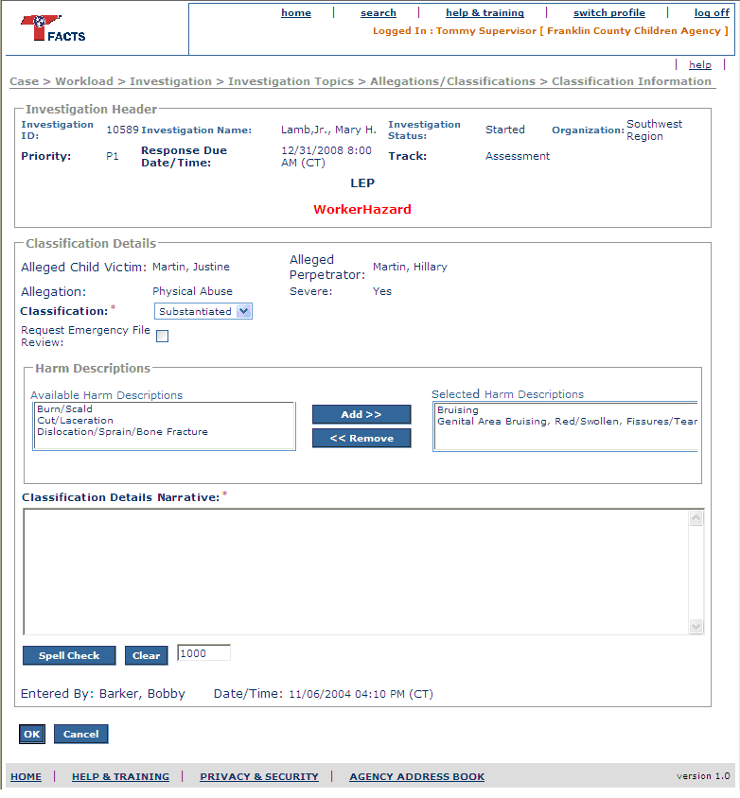
Figure 7 – Classification Details – Existing Screen Mock Up

    - To Be – Screen Mock Up
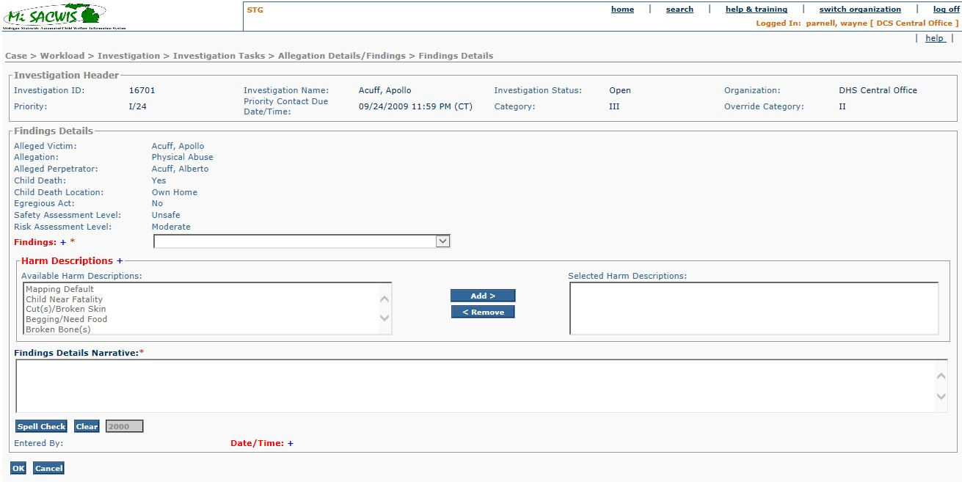Figure 8 – Classification Details – Updated Screen Mock Up
    - Screen Fields
Status (Unchanged/ Add/ Modify/ Delete) | As Is Class.Attribute Name |  | To Be Class.Attribute Name | As Is Display Name | To Be Display Name | To Be Type | To Be Align | To Be Size | To Be Read Only | To Be Calculation | To Be Edit Mask | To Be UI Validation
- See Header Information in section 3.1.3
Modify | N/A | N/A |  | Classification Details | Findings Details | Group Box Header | L | N/A | T | N/A | N/A | N/A
Modify | INVESTIGATIONALLEGATION.allegedChildVictim | INVESTIGATIONALLEGATION.allegedChildVictim |  | Alleged Child Victim | Alleged Victim | Display text | L | 22 | T | N/A | Last Name, First Name MI | N/A
Keep | INVESTIGATIONALLEGATION.allegedPerpetrator | INVESTIGATIONALLEGATION.allegedPerpetrator |  | Alleged Perpetrator | Alleged Perpetrator | Display text | L | 22 | T | N/A | Last Name, First Name MI | N/A
Keep | ALLEGATIONCLASSIFICATION.allegationTypeCode | ALLEGATIONCLASSIFICATION.allegationTypeCode |  | Allegation | Allegation | Display text | L | 30 | T | N/A | Domain code=AllegationType | N/A
Delete | N/A | AllegationClassification.allegationSuperTypeCode |  | N/A | Allegation Type | Display text | L | 100 | T | N/A | Domain code=AllegationCategory | N/A
Modify | ALLEGATIONCLASSIFICATION.classificationTypeCode | ALLEGATIONCLASSIFICATION.classificationTypeCode |  | Classification | Findings | Drop Down List | L | 100 | F | Domain Code:  ClassificationType | N/A | User selected  See BR 1  Required Field
Delete | ALLEGATIONCLASSIFICATION.emergFileReviewFlag | ALLEGATIONCLASSIFICATION.emergFileReviewFlag |  | Request Emergency File Review | Request Emergency File Review | Checkbox | L | N/A | F | N/A | N/A | User input  See BR2.
Add | N/A | AllegationClassification.childDeathFlag |  | N/A | Child Death: | Display text | L | 100 | T | Domain code = YesNo  1 = Yes, 0 = No | N/A | N/A
Add | N/A | AllegationClassification.childDeathLocation |  | N/A | Child Death Location: | Display text | L | 100 | T | Domain code = ChildDeathLocation | N/A | N/A
Modify | ALLEGATIONCLASSIFICATION.severeFlag | ALLEGATIONCLASSIFICATION.severeFlag |  | Severe | Egregious Act | Display text | L | 22 | T | N/A | N/A | N/A
Keep | N/A | N/A |  | Harm Descriptions | Harm Descriptions | Group Box Header | L | N/A | T | N/A | N/A | N/A
Keep | HARMDESCRIPTIONS.harmDescriptionsCode | HARMDESCRIPTIONS.harmDescriptionsCode |  | Available Harm Descriptions | Available Harm Descriptions | Mover Box | L | 30 | F | Domain Code:  HarmDescription | N/A | System populated  User selected  Not required
Keep | HARMDESCRIPTIONS.harmDescriptionsCode | HARMDESCRIPTIONS.harmDescriptionsCode |  | SelectedHarm Descriptions | SelectedHarm Descriptions | Mover Box | L | 30 | F | N/A | N/A | User selected  Not required
Modify | ALLEGATIONCLASSIFICATION.classificationNarrative | ALLEGATIONCLASSIFICATION.classificationNarrative |  | Classification Details Narrative | Findings Details Narrative | Text field | L | 2000 | F | N/A | N/A | User input  Required Field
Keep | ALLEGATIONCLASSIFICATION.createdBy | ALLEGATIONCLASSIFICATION.createdBy |  | Entered By | Entered By | Display text | L | 22 | T | N/A | Last Name, First Name MI | Shows the name of the logged in worker that entered the classification  Will be populated when the 'classifyfinding' hyperlink is clicked on IV13-S02 for the first time.
Keep | ALLEGATIONCLASSIFICATION.createdDate | ALLEGATIONCLASSIFICATION.createdDate |  | Date/Time | Date/Time | Display text | L | 24 | T | N/A | MM/DD/YYYY ##:## XM (TZ) | Date and time that the classification was entered  Will be populated when the classifyfinding hyperlink is clicked on IV13-S02 for the first time.
Add | N/A | SafetyResponse.SafetyDecision |  | N/A | Safety Assessment level: | Display text | L | 100 | T | N/A | N/A | N/A
Add | N/A | RiskAssessment.FinalRiskLevelCode |  | N/A | Risk Assessment level: | Display text | L | 100 | T | N/A | N/A | N/A

    - Action Buttons
Status (Keep/ Add/ Modify/ Delete) | Label | Type | On Click Action/Navigation | Tab Order
Keep | Ok | Button | Caches Data; Returns to IV13 – S02 Classification Information
Keep | Spell Check | Button | Launches Spell Check Functionality
Keep | Clear | Button | Clears information entered in Classification Details Narrative.
Keep | Cancel | Button | Does not accept data entered and removes the page/screen; Returns to IV13 – S02 Classification Information
Modify | Add > | Button | Moves selected choice(s) from Available Harm Description mover box to Selected Harm Description mover box.
Modify | < Remove | Button | Moves selected choice(s) from Selected Harm Description mover box to Available Harm Description mover box.
    - Business Rules
No. | Status (Keep/ Add/ Modify/ Delete) | Business Rule Description | Modified Business Rule Description | Execution Event (field tab out/save etc) | Error Msg Code  To be completed by Development Team
1 | Keep | If Track(Header)=Assessment then use Assessment classification values in domain code ClassificationCategory  If Track(Header)=Investigation or Special Investigation(SIU) then use Investigation classification values in domain code ClassificationCategory |  | Page Load
2 | Keep | When “Request Emergency File Review” checkbox is selected and classification is anything other than “Allegation Indicated/Perpetrator Indicated” then display error message. |  | OK
    - Security Requirements
No. | Status (Keep/Add/Modify/Delete) | Security Requirement
1 | Keep | Create:  CPS Field Hierarchy – Non SIU – (1 being the top of the pyramid with the person having the most rights) (if a CPS assignment role to case)  - CPS Override Worker  - CPS Management  - CPS Team Leader (Non SIU)  - CPS County Supervisor (Non SIU) / Pool Cleaner  - CPS Linker  - CPS Worker  CPS/SIU Field Hierarchy – (1 being the top of the pyramid with the person having the most rights) (if a CPS/SIU assignment role to case)  - CPS/SIU Override Worker  - CPS/SIU Management  - CPS/SIU Team Leader  - CPS/SIU County Supervisor/Pool Cleaner  - CPS/SIU Worker
2 | Keep | Read:  For non-SIU, Anyone with assignment to the case/investigation can read this screen.  Central Intake Hierarchy – (1 being the top of the pyramid with the person having the most rights)  - Central Intake Override Worker  - Shift Supervisory/Shift Leader  - Intake Specialist  - CPS/SIU Intake Reader  CPS Field Hierarchy – Non SIU – (1 being the top of the pyramid with the person having the most rights) (if a CPS assignment role to case/investigation)  - CPS Override Worker  - CPS Management  - CPS Team Leader (Non SIU)  - CPS County Supervisor (Non SIU) / Pool Cleaner  - CPS Linker  - CPS Worker  - CPS Intake Reader  CPS Auditor(Non SIU)  CPS/SIU Field Hierarchy – (1 being the top of the pyramid with the person having the most rights) (if a CPS/SIU assignment role to case/investigation)  - CPS/SIU Override Worker  - CPS/SIU Management  - CPS/SIU Team Leader  - CPS/SIU County Supervisor/Pool Cleaner  - CPS/SIU Worker  - CPS/SIU Intake Reader  - CPS/SIU Central Office Auditor
    - Screen Navigation
No. | Status (Keep/Add/Modify/Delete) | To Screen Navigation Path
1 | Modify | Case>Workload>Investigation>Investigation Topics Tasks >Allegations/Classifications hyperlink>Classification Findings Information hyperlink>’classify’ Allegation hyperlink
2 | Modify | Search Hyperlink>Case>Click Hyperlink for desired investigation>Investigation Topics Tasks >Allegations/Classifications Findings hyperlink Classification Findings Information hyperlink> ’classifyfindings’ Allegation hyperlink
3 | Modify | Case>Workload>Case>Investigation Linked>Investigation ID>Investigation Topics Tasks > Allegations/Classifications hyperlink>’select’ Allegation Hyperlink
    - Pre-Conditions
No. | Status (Keep/Add/Modify/Delete) | Pre-Condition
1 | Keep | Investigation must exist
2 | Keep | Investigation needs to be tracked as “Investigation”, “Assessment”, or “Special Investigation(SIU)”
    - Reference Values
No. | Status (Keep/Add/Modify/Delete) | To Be Class Attribute | Domain Code | Short Desc | Ref Data Code
1 | Keep |  | ClassificationType
2 | Keep |  | HarmDescription

    - Notes and Assumptions
N/A

